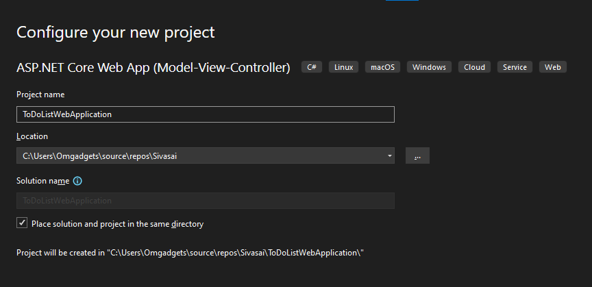

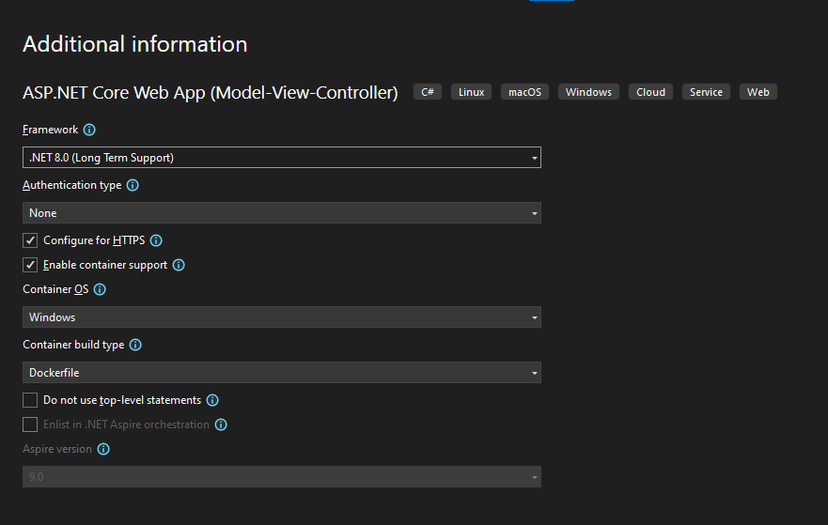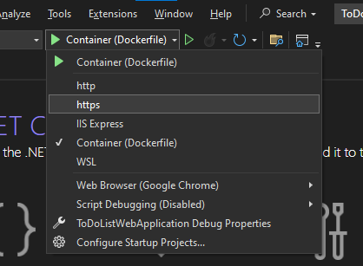

* Can change the port number according to the Run Type (Https, http, docker container) in the following file

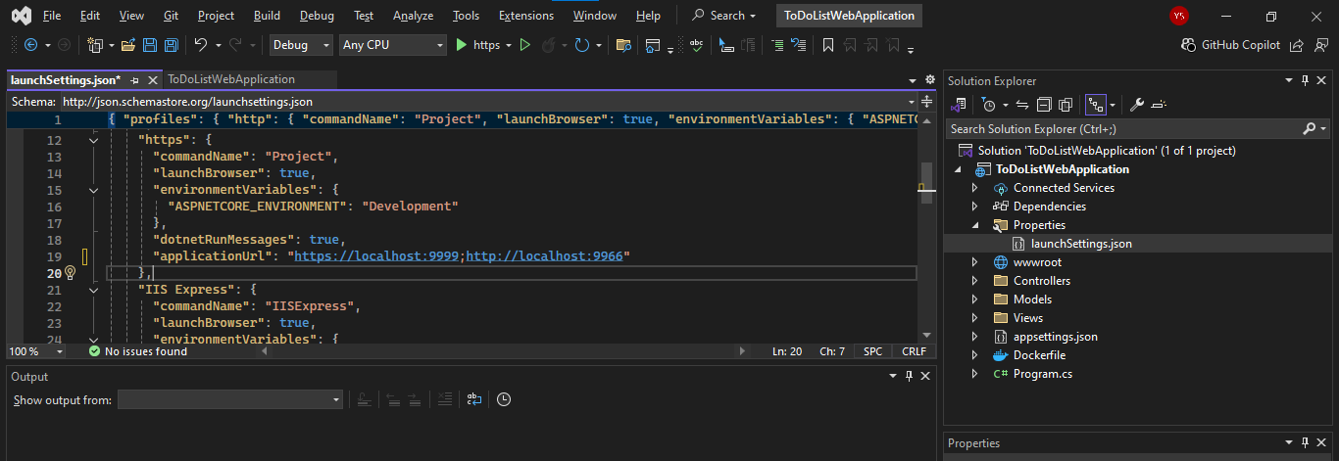

* Can change the Tab name in all the tabs globally

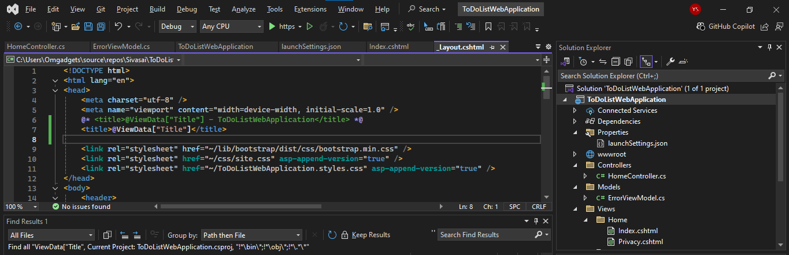

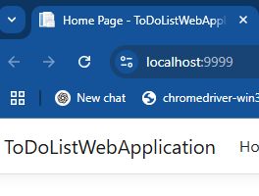

After



* Can change the default Page to come up while running

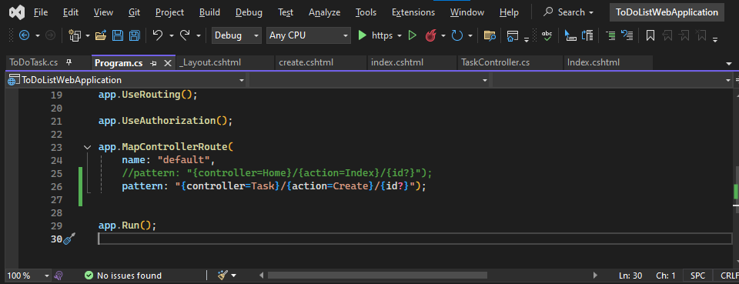

For Exe , without .Net Installed

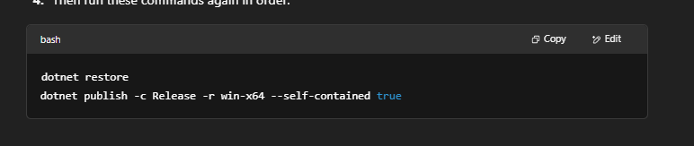

If not working check the .csproj file for the configurations

